2023 SMSHS Year 11 Physics Marking Criteria

|  |  |  |  |  |  |  |  |  |  |  |  |  |  |  |  |  |  |  |  |
| --- | --- | --- | --- | --- | --- | --- | --- | --- | --- | --- | --- | --- | --- | --- | --- | --- | --- | --- | --- |
| 1 | 2 | 3 | 4 | 5 | 6 | 7 | 8 | 9 | 10 | 11 | 12 | 13 | 14 | 15 | 16 | 17 | 18 | 19 | 20 |
| B | D | A | B | A | B | D | B | A | D | A | C | C | B | B | C | C | D | B | D |

**Question 21**

a)

|  |  |
| --- | --- |
| **Criteria** | **Marks** |
| * Correctly identifies the type of motion displayed in the graph | 1 |

***Sample answer***

The graph clearly shows uniformly **accelerated** motion as the displacement in the graph is not just increasing, it is increasing exponentially.

OR

The graph shows constant acceleration up until p before reaching a constant velocity.

b)

|  |  |
| --- | --- |
| **Criteria** | **Mark** |
| * Correctly identifies that instantaneous velocity is determined if a tangent was drawn at P | 1 |

**Sample Answer:**

If a tangent was drawn at point P we can determine the object’s instantaneous velocity by calculating gradient of this tangent.

c)

|  |  |
| --- | --- |
| **Criteria** | **Mark** |
| * Correctly explains that the object’s acceleration can be calculated by comparing the value of the gradient/instantaneous velocity using the tangent at two points such as P and Q | 2 |
| * Provides some relevant information | 1 |

**Sample Answer:**

This can be determined by calculating a value for the gradient of the tangent at two points such as P and Q giving us the instantaneous velocity for each. The difference can then be used in the formula: a = $\frac{v-u}{t}$ to calculate the acceleration between these two points.

CAN MENTION USING A VELOCITY TIME GRAPH.

**Question 22**

|  |  |
| --- | --- |
| **Criteria** | **Mark** |
| * Identifies that students have included their outlier results | 1 |

a)

**Sample Answer:**

The students have included their inconsistent results in their calculations of averages. Outliers should not be included in the calculations.

|  |  |
| --- | --- |
| **Criteria** | **Mark** |
| * Correctly calculates the average time EXCLUDING the outlier. * Correctly calculates the correct acceleration due to gravity | 2 |
| * Correctly calculates the average time EXCLUDING the outlier. **OR** * Correctly calculates the correct acceleration due to gravity | 1 |

b)

**Sample Answer:**

Average velocity = (0.94 + 0.88 + 0.85)/3 = 0.89

Acceleration 🡪 By s=ut+1/2at2, with u=0, = 10.10 ms-2

|  |  |
| --- | --- |
| **Criteria** | **Mark** |
| * Correctly identifies which type of ball has the most accurate acceleration value and provides sufficient justification | 2 |
| * Provides some relevant information | 1 |

c)

**Sample Answer:**

The golf ball has the most accurate acceleration due to gravity. We can see this as the measured acceleration of 9.88 ms-2 is the closest of all the balls to the accepted literature value of 9.8 ms-1.

|  |  |
| --- | --- |
| **Criteria** | **Mark** |
| * Correctly identifies which type of ball has the most reliable acceleration value with sufficient justification. | 2 |
| * Provides some relevant information | 1 |

d)

**Sample Answer:**

Reliable results need to be both accurate and reproducible. The golf ball’s drop times of 0.88 s, 0.93 s, 0.91 s and 0.89 s have the least spread of all the balls of only 0.05, being very reproducible makes the golf ball results the most reliable. VALUES NOT NEEDED.

All the other types of balls have a much greater spread; tennis 0.4, baseball 0.53, soft ball 0.77 and squash ball 0.33 so give average results that are not as accurate.

e)

|  |  |
| --- | --- |
| **Criteria** | **Mark** |
| * Justifies an improvement that can be used to improve the accuracy of the data gathered. | 2 |
| * Suggests an improvement that can be used to improve the accuracy of the data gathered. | 1 |

**Sample Answer:**

By filming the ball falling and using the start and end times of the video, the students could gather more accurate data as their measurements would not be affected by human reaction time in starting and stopping the stopwatches.

Because question says gathered data, it has to be something related to gathering it in the procedure, not calculating an average.

MAYBE 1 mark for something about removing outliers, or reliability. 🡪 Base on how they’re going.

**Question 23**

|  |  |
| --- | --- |
| * 1 correct equation and substitutions of correct data. * Accurate answer * Unit and direction | **3** |
|  | **2** |
|  | **1** |

**Sample Answer**

Time to catch up = 900 m/9.0 m s-1 = 100 s but starting time for **B** is 20.0 s later, so t = 80 s

Use: u=0, s=900 m, t=80 s : Find a: s = ut + 1/2at2

900 = 0 + 1/2a x 802

a= 1800/6400

a= 0.28 m s-2 right

**Question 24**

a)

|  |  |
| --- | --- |
| **Criteria** | **Mark** |
| * Draws vector diagram to scale (with a specific scale). * Calculates the relative velocity of the white train relative to the black train. (Either by calculation or by measuring their scale drawing). | 2 |
| * 1 of the above. | 1 |

**Sample Answer:**

v­w rel b= vw-vb = vw+(-vb) Scale = 2 m :1 cm

vw = 28ms-1 Right

-Vb= 14ms-1 Left

vw+(-vb)= 28 – 14 = 14 ms-1 Right

a)

|  |  |
| --- | --- |
| **Criteria** | **Mark** |
| * Provides the opposite answer to the question above. | 1 |

**Sample:** The black train is moving 14 ms-1 Left relative to the white train.

**Question 25**

|  |  |
| --- | --- |
| **Criteria** | **Mark** |
| * Calculates and identifies all horizontal and vertical components correctly | 3 |
| * Calculates most horizontal and vertical components correctly | 2 |
| * Provides some horizontal and vertical components correctly | 1 |

a)

**Sample Answer:**

|  |  |  |  |
| --- | --- | --- | --- |
|  | *RED* | *BLUE* | *WHITE* |
| *Horizontal Component* | -210 cos 120  = -105 N | 190 Cos 120o  = -95 N | 200 N |
| *Vertical Component* | -210 sin 120  = -181.865 | 190 Sin 120o  = 164.5 N | 0 N |

**Question 25**

b)

|  |  |
| --- | --- |
| **Criteria** | **Mark** |
| * Creates a vector or free body diagram with: * All vertical components. * All horizontal components * Drawn following conventions (ruler, pencil, arrows, labels, etc) * Correct calculation of net force. | 4 |
| * 3 of the above | 3 |
| * 2 of the above | 2 |
| * One of the above | 1 |

**Sample Answer:**

200 N

164.5 N

105 N + 95 N

181.87 N

Net Force = 17.37 N Down

**Question 26**

a)

|  |  |
| --- | --- |
| **Criteria** | **Mark** |
| * Correctly calculates the velocity of the two trolleys after the collision. This includes direction specified | 2 |
| * Correct method for determining the final velocity with an error | 1 |

**Sample Answer:**

m1= 8 kg. m2 = 2.5 kg u1 = 15 m.s-1 u2 = 6 m.s-1

m1u­1 + m2u­2 = m1v1 + m2v­2 🡪 (8x15) + (2.5x6) = m1v1 + m2v­2 Since they stick together, v1 = v2 = v.

Therefore, 135 = m1v + m2v­ = (m1 + m2)v. Therefore v=135/10.5 = 12.9 m/s to the right.

b)

|  |  |
| --- | --- |
| **Criteria** | **Mark** |
| * Correctly determines the time taken to stop. | 1 |

**Sample Answer:**

Δp=F x Δt. Since the final momentum of the combined mass is 0 (since v= 0 ms-1 ).

Δp= 0-135 = -135 kg.m.s-1

135 kg.m.s-1 = F x Δt = -0.9 x Δt

Therefore Δt = -135/-0.9 = 150 seconds.

**Question 27**

|  |  |
| --- | --- |
| **Criteria** | **Mark** |
| * Calculates the kinetic energy of the arrow when it reaches the ground | 3 |
| * Calculates the initial kinetic and potential energy.  OR * Calculates the velocity of the arrow when it reaches the ground | 2 |
| * Shows some relevant working. | 1 |

**Sample Answer:**

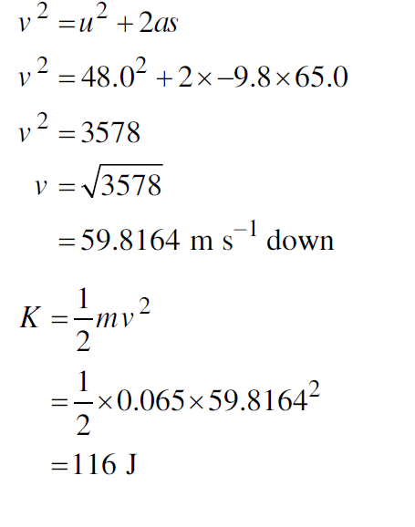

Uinitial = mgh = 0.065 kg x 9.8 ms-1x 65m

= 41.405 J

Kinitial = ½ mv2 = ½ x 0.065 kg x 482 = 74.88 J

Einitial = K initial +U initial = 116.23 J

Since Einitial = Efinal (because energy is conserved)

Efinal = 116.26 J = 116 J

OR

**Question 28**

a)

|  |  |
| --- | --- |
| **Criteria** | **Mark** |
| * Identifies that the data shows an inverse relationship. * Assesses that the data is inaccurate by referring to *I* ∝ 1/r2 | 3 |
| * Assesses that the data is inaccurate by referring to *I* ∝ 1/r2 | 2 |
| * Provides some relevant information. | 1 |

**Sample Answer:**

The data suggests that there is an inverse relationship between distance and light intensity.

However, the mathematical model *I* ∝ 1/r2  shows that there should be an inverse square relationship between

distance and light intensity, meaning that the data is inaccurate.

b)

|  |  |
| --- | --- |
| **Criteria** | **Mark** |
| * Labels axes AND includes units. * Uses an appropriate scale. * Plots all data points. * Draws an appropriate trendline | 4 |
| * Three of the above. | 3 |
| * Two of the above. | 2 |
| * One of the above. | 1 |

**Sample Answer:**

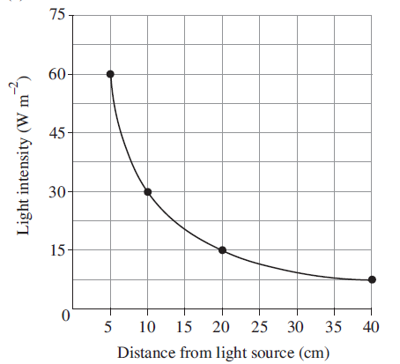

**Question 29**

|  |  |
| --- | --- |
| **Criteria** | **Mark** |
| * Determines the period | 1 |

a)

**Sample Answer:**

Period, T = 3.6 seconds

|  |  |
| --- | --- |
| **Criteria** | **Mark** |
| * Determines the amplitude | 1 |

b)

**Sample Answer:**

|  |  |
| --- | --- |
| **Criteria** | **Mark** |
| * Determines the speed of the wave. | 2 |
| * Provides some relevant working. | 1 |

Amplitude = 1.0 m

c)

**Sample Answer:**

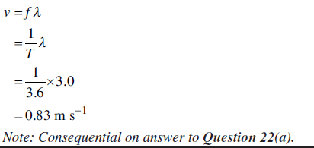

**Question 30**

|  |  |
| --- | --- |
| **Criteria** | **Mark** |
| * Ray diagram shows ray of light coming from the fish refracting away from the normal towards the eye of the person. * Ray diagram extends the refracted ray into the water, showing where the light ray appears to have come from. * Apparent position of fish shown to be above/ behind original position. | 3 |
| * Two of the above. | 2 |
| * One of the above. | 1 |

**Sample Answer:**

Apparent position of fish

Refracted ray

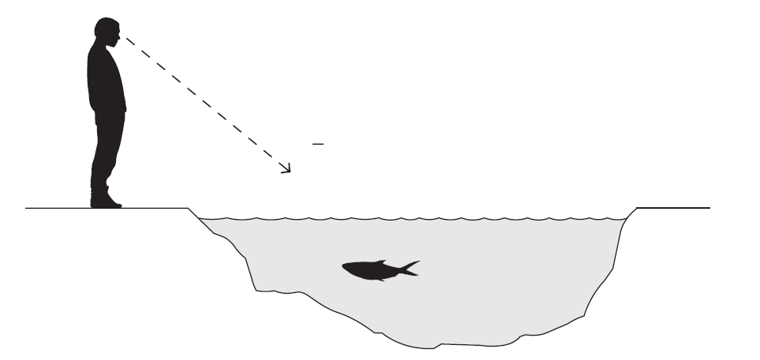

**Question 31**

a)

|  |  |
| --- | --- |
| **Criteria** | **Mark** |
| * Draws field lines going AWAY from charge q since it is a positive charge. * Draws field lines following conventions (touching point charge, spreading radially, using a ruler, in pencil, etc). | 2 |
| * One of the above. | 1 |

**Sample Answer:**

**Question 32**

a)

|  |  |
| --- | --- |
| **Criteria** | **Mark** |
| * Correctly calculates the electric field strength | 1 |

**Sample Answer:**

E=V/d =6/1.5 = 4 V m-1

b)

|  |  |
| --- | --- |
| **Criteria** | **Mark** |
| * Correctly compares magnitude of the force on each particle * Correctly compares direction of the force on each particle, specifying the direction. * Correctly compares the work done on each particle. Must specify that Work done on B is double the work done on A, not just “higher” or “lower”. | 3 |
| * Two of the above. | 2 |
| * One of the above. | 1 |

**Sample Answer:**

|  |  |  |
| --- | --- | --- |
|  | **Particle A** | **Particle B** |
| **Magnitude of force** | Equal to B | Equal to A |
| **Direction of force** | Up | Up |
| **Work Done** | Half of B. | Twice A. |

c)

|  |  |
| --- | --- |
| **Criteria** | **Mark** |
| * Correctly assesses that the statement is incorrect and supports this with clear calculations. | 3 |
| * Correctly assesses that the statement is incorrect and completes some relevant calculations. | 2 |
| * Correctly assesses that the statement is incorrect. OR * Completes some relevant calculations. | 1 |

**Sample Answer:**

The statement made by the student is incorrect. Since the work done on B is twice that of A, it will have twice the kinetic energy of A once they both reach the top plate. We can see below, that this means that the velocity of A is not half of B, but is in fact 71% of B.

2KA=KB

2 x ½mvA2 = ½mvB2

2 x vA2 = vB2